MODULE 4 QUES 1
https://www.hackerearth.com/problem/algorithm/digit-sum-4/
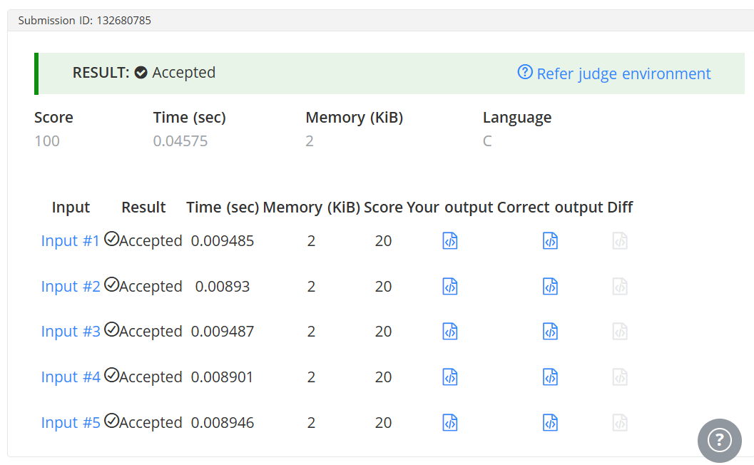
CODE
#include <stdio.h>
int main() {
int T;
// Read the number of test cases
if (scanf("%d", &T) != 1) return 0;

while (T--) {
int N;
// Read the integer N for the current test case
if (scanf("%d", &N) != 1) continue;

// Find the last digit
int last_digit = N % 10;

// Find the first digit by dividing N by 10 until it is less than 10
int first_digit = N;
while (first_digit >= 10) {
first_digit /= 10;
}

// Calculate and print the sum
int sum = first_digit + last_digit;
printf("%d\n", sum);
}

return 0;
}

